Ryhill Junior, Infant and Nursery School

Chapel Street, Ryhill, Nr. Wakefield, W. Yorks. WF4 2AD
Telephone: 01226 722530 Fax: 01226 727969
Email: headteacher@ryhill.wakefield.sch.uk
HEADTEACHER: Mrs E Jones

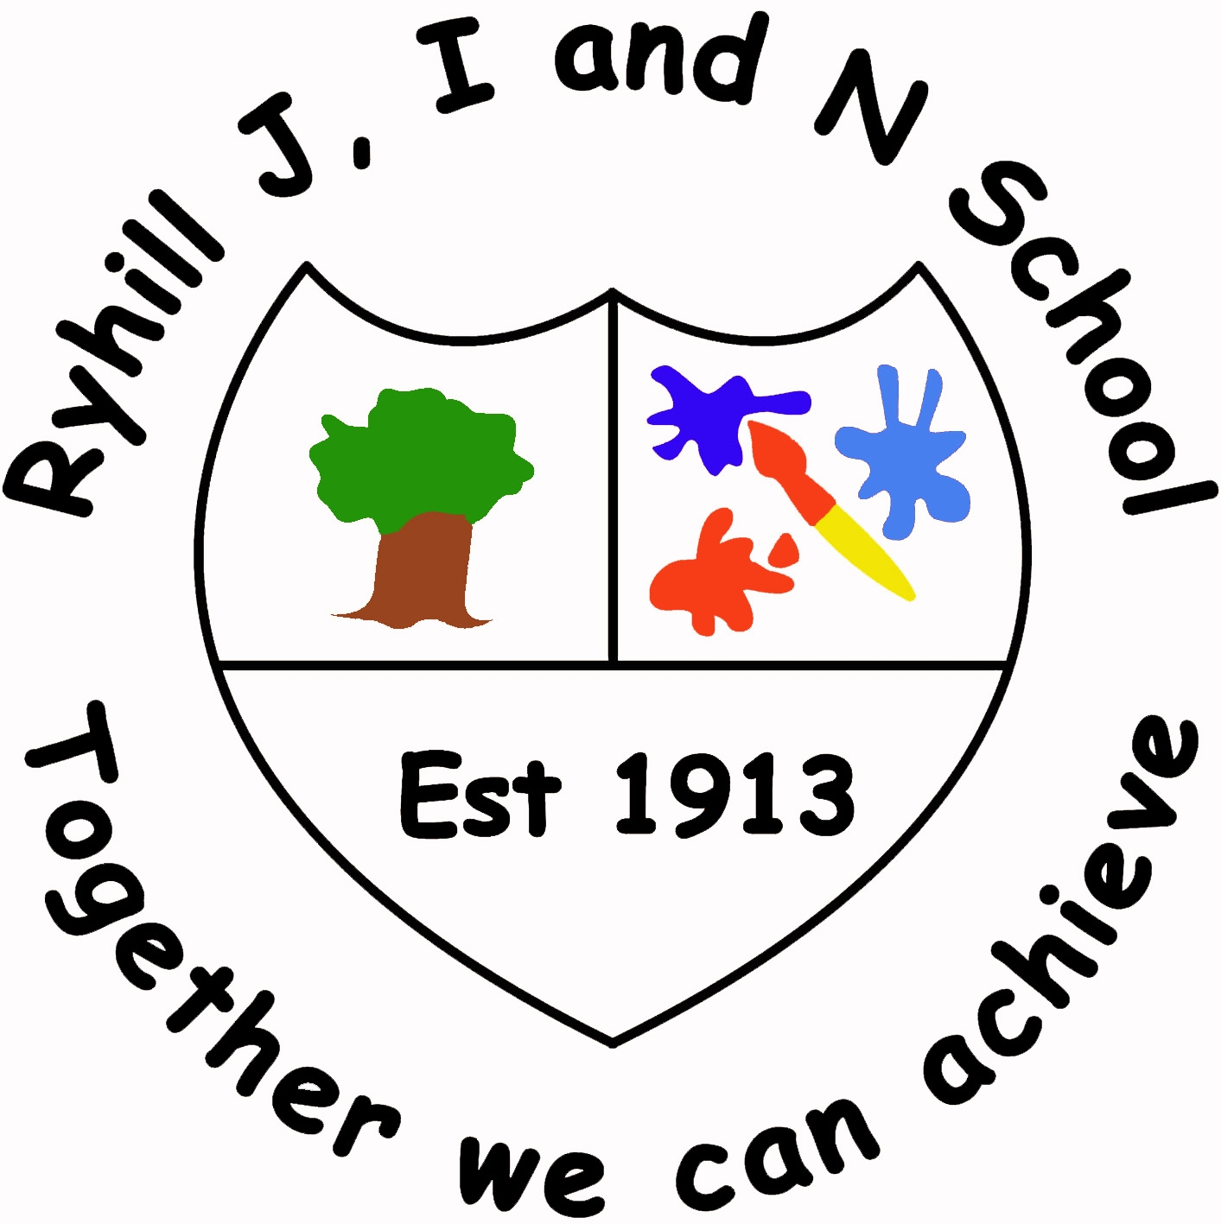

25th November 2016,

Dear children at Ryhill J& I School,
Thank you all so much for the letters you have been writing to me recently. If you haven’t had chance to write yours yet don’t worry there is still plenty of time! Now I have noticed on lots of children’s lists this year that lots of you would like electronic gifts such as Playstations, X-boxes, I-Pads, Kindles and tablets. These are very expensive presents and it is important that you know how to use them safely so Mrs Jones has asked me to give you some top tips on how to stay safe online this Christmas

- Make sure a grown up takes a look at the control panel on your new device to make sure all the settings are safe for children, my friends at the internet matters site have a special page to help you! http://www.internetmatters.org/controls/
- If you need an account for a device let your grown up set it up for you in their name then they can check the games and apps you download are safe.
- Always ask a grown up before you download an app. Some apps like Facebook or Snapchat have an age limit on them and you will be too young. Grown ups can check the suitability of apps here http://www.net-aware.org.uk/#
- Always talk about staying safe online with a grown up, have a look at my elves top tips!
Remember:
Always be nice to people on the computer like you would be in the playground.
Remember:
Always keep your personal information private, don’t tell other people.

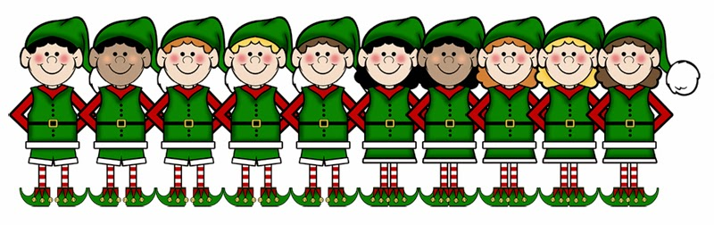

Remember:
People you don’t know are strangers. They are not always who say they are.
Remember:
If you ever get that “Uh-oh” feeling, you should always tell a grown up.
Well boys and girls the elves are calling me back to the workshop so I must be off! Just one thing before I head off, Mrs Jones has asked me to let you know that if you or your grown up has any questions please let her know as she will be happy to help!

Love Santa x

